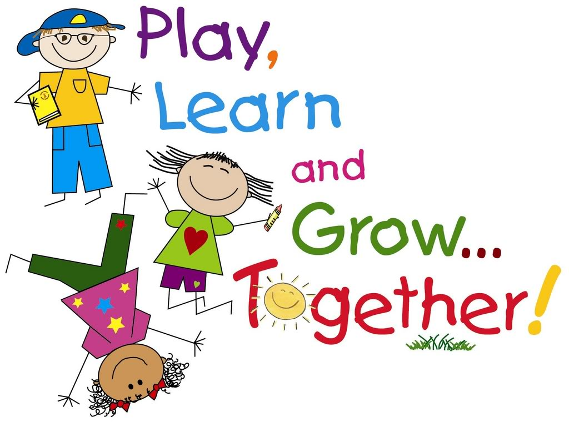

* _____ Face Masks (Disposable or Reusable)
* _____ Pull-ups with SIDE closure (if necessary) – NO DIAPERS
* _____ 1 Large Book Bag - no wheels
* ­­­_____ 2 Packs of Baby Wipes – Please NO EQUATE BRAND!!!
* _____ 2 Boxes of large Ziploc bags
* _____ 2 Boxes of small Ziploc bags
* _____ 5 Rolls of Paper Towels
* _____ 5 Boxes of Kleenex (Pocket Size)
* _____ 3 Bottles of Hand Sanitizer
* _____ 2 Containers of Disinfecting Wipes (ex. Clorox wipes)
* _____ 2 Boxes of Vinyl Gloves (LATEX FREE)
* 1 complete change of clothing (top, bottom, underwear & socks) - this is extremely important. If your child is changed at school throughout the year PLEASE SEND A NEW set of clothing the VERY NEXT DAY! These do not have to be school colors.
* Please put your child’s name on ALL supplies.
* All Teachers will have supply baskets for students.
* REPLACEMENT of supplies during the year is the student’s responsibility.